NOMADIC TRIKE DESCRIPTION ITEMS AND PRICE.

OPTION 1 BASIC STYLE 4379 USD – NO ENGINE & PROPELLER NO ACCESORIES
Designed for adventure paramotoring and exploration in remote environments. Its large tires provide a smooth ride over rough terrain and allow for trouble-free takeoffs and landings on challenging ground.
The pilot sits several inches above the passenger, allowing for better visibility and easier landings.
Its parts are laser-cut for greater precision and fit, and made of stainless steel, the Nomadic is incredibly strong yet lightweight, weighing only 45 kg dry without the engine.

Its innovative in-flight adjustable attachment point system (from tandem to single) allows parachutists to jump. This system provides better weight distribution, ensuring superior balance and control. Because the entire frame is attached to the seat base by a 4-ton resistance wire and a second control point in the gravity adjustment system, this results in less sway and more control, and comfortable passengers who can relax and enjoy the flight.

Experience unparalleled comfort with a harness designed for safety and freedom of movement.

Compatible with all high-end paramotor engines, including the Vittorazi Cosmos 300, Polini Thor 303/260/202, Zeus 300, and Simoni Victor 1 54hp, and many more! Thanks to its motor mount.

It keeps the pilot and passengers safely inside the frame, increasing protection in case of a rollover thanks to the trike's unique reinforcement design.

Independent passenger footrests prevent unintentional turns, while the pilot controls the front fork during taxiing and takeoff. The steering tube angle and fork offset are designed to make the trike agile at low speeds and stable at high speeds.

A front disc brake has been added for greater safety; you no longer need to perform complicated maneuvers to stop.

The Nomadic is designed to be incredibly simple and intuitive to assemble and disassemble. A simple and ingenious system of matching icons makes assembling the components a breeze, making the whole process a piece of cake!

The rear axles are telescopic, making them easy to transport in the back of a large pickup truck, and one person can easily load them up an ATV ramp.ALL THIS CARACTERISTICAS

Standard Chassis Package
What's Included

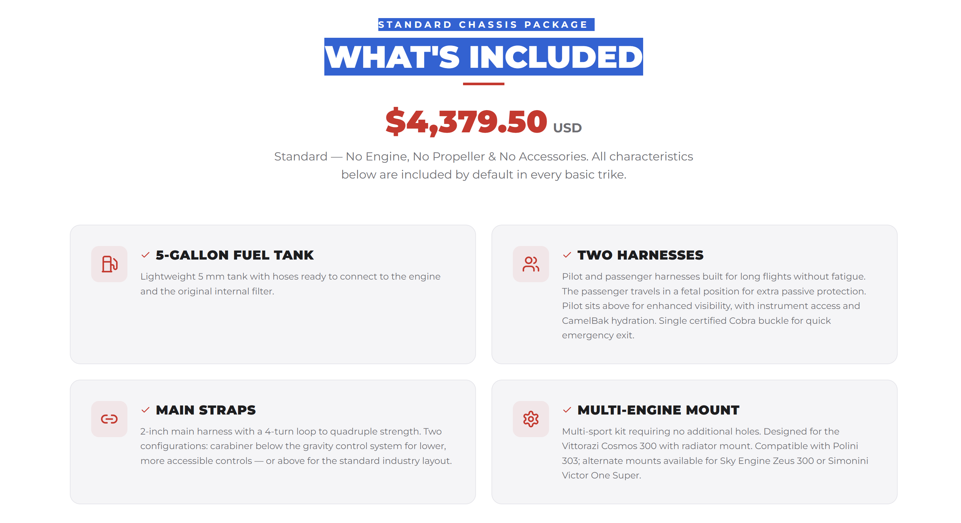

INCLUIR EL CHSIS
CHASIS: Nomadic chasis con sus ruedas tipo tundra, eje telescópico trasero en aluminio Aeronautico 7075, multi soporte de motor para vittorazi cosmos 300 y polinis, o soporte de motor para sky engine Zeus o Simonini victor 1 super, solo uno por chsis.

SECCION DE CUSTOMIZACION
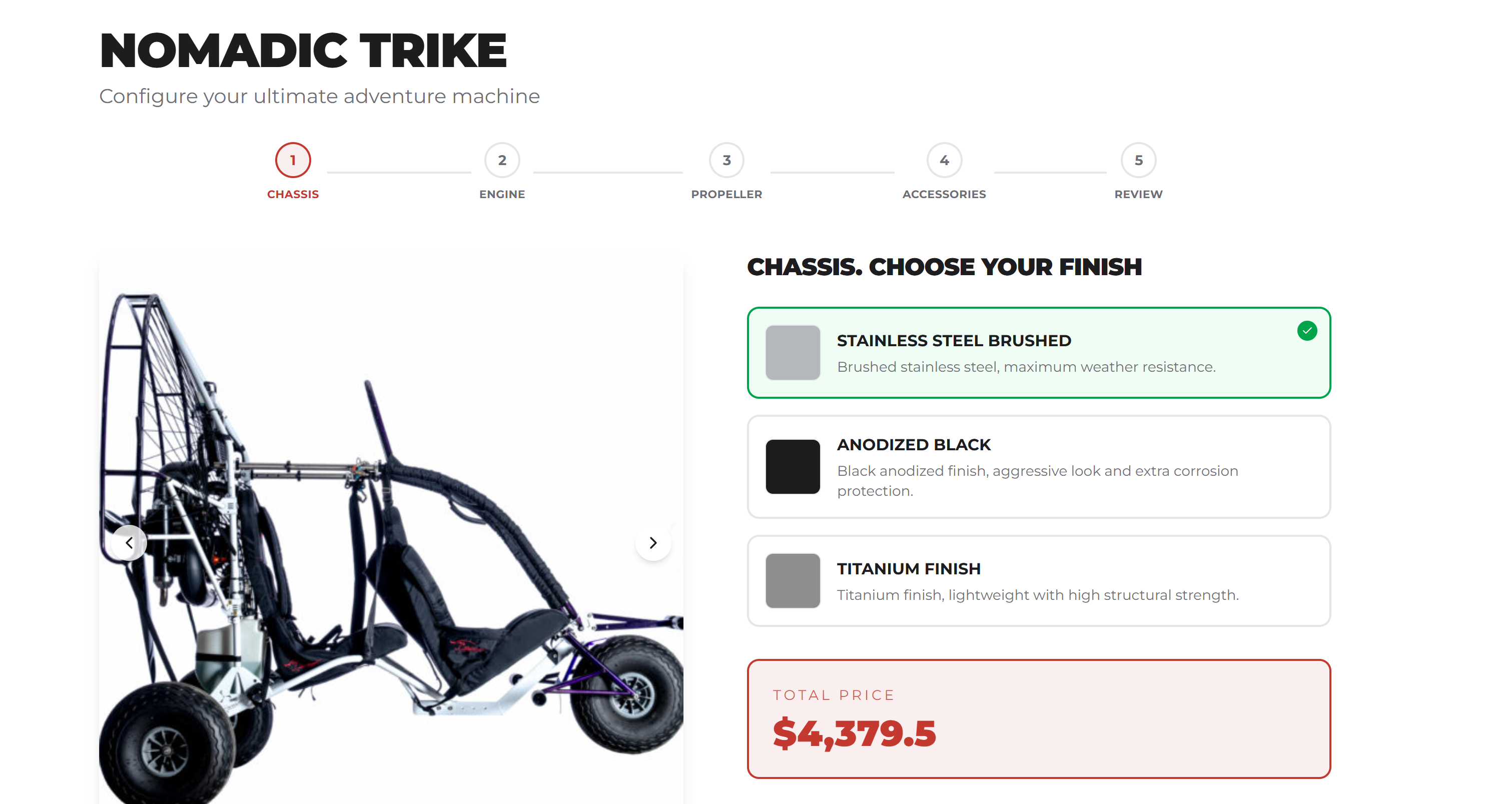
1-CHOSE A COLOR
- (DEACUERDO AL COLOR ELEJIDO LAS FOTOS DEBEN CAMBIAR POR EL COLOR ESCOJIDO) sin embargo se deben colocar 3-4 fotos en el recuadro verde y que se amplíen. (las fotos deben ser del modelo sencillo son accesorios.
- Para el futuro en el recuadro de la derecha se va a colcar el modelo 3D y este debe cambiar deacuerdo a lo escogido en color, motor propeler y accesorios.

- RED CANDY AND WHITE.
- BLUE CANDY AND WHITE
- PURPLE CANDY AND WHITE

2- Chassis. CHOOSE YOUR FLYING STYLE (NO APLICA PARA EL NOMADIC)
A-(CAMBIAR POR ESTE TITULO)
B- como esta dividido en dos secciones, la sección que esta en verde debe tener 3-4 fotos y que se pueda ampliar cada FOTO dando un clip o como lesquede mas fácil HACER ESTE PROCESO, pero que sa fácil para el usuario, en la sección de la derecha debe estar el modelo 3D ya que será la sunda etapa de este proyecto.

B-AL MOMETO DE HACER EL 3D EL DISENO DEBE CAMBIAR DEACUERDO DE ACUERDO AL TIPO DE VUELO ESCOJIDO (COMERCIAL, ADVENTURE O REPORTAIR).

- COMERCIAL: Designed for tandem flying, the passenger has easy access from the front. The passenger harness is comfortable and positions the passenger deep inside the trike, providing safety as their head is below the bars. The passenger's foot support does not interfere with the pilot's taxiing. This type of trike allows for the attachment of accessories such as a bar protector with a special padded handle for the passenger.

- ADVENTURE : Designed for pilots who want to fly far and fast, its dynamic style allows for more penetration and less drag, making the wing more efficient. This type of flight is ideal for adventurers, and

- REPORTAIR: Designed for maximum passenger visibility and the exclusive option of mounting a camera with a rotating bracket. Also, if you enjoy hunting, you can add a weapon mount, as the passenger will have full access to the right or left side.

3- ENGINE
- CADA MOTOR DEBE TENER SUS TRES O 4 FOTOS EN LA SECCION VERDE Y LA DESCRIPCION DEL MOTOR JUNTO CON UN LINK PARA BRINDAR MAS INFO SI EL CLINTE LO DESEA. ADICIONO EL LINK PARA COLOCARLO EN LA DESCRIPCION, CADA FOTO DEBE SER AMPLIABLE COMO ACORDAMOS.
- A LA DERECHA SE DEBE COLOCAR EL MODELO EN 3D CON EL MOTOR ELEJIDO PARA SEGUNDA ETAPA DE ESTE PROJECTO.
- EL PRECIO DEL MOTOR DEBES DARME LA OPCION DE CAMBIALO DE MANERA FACIL . YA QUELO PRECIOS ESTAN POR COREGIR YA QUE ESTOY TRAMITANDO SER DEALER.
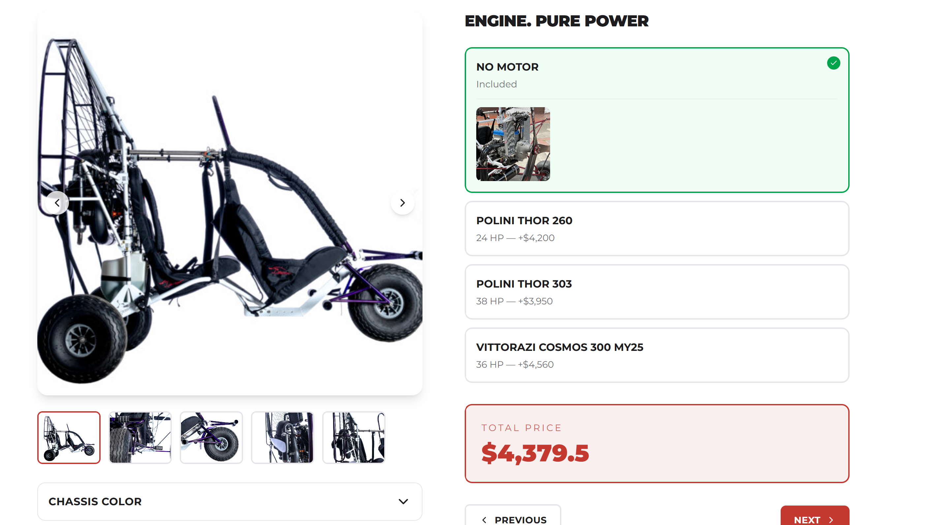

- Polini thor 260………………….. $5455. USD
Polini Motori officially presents the new THOR 260, a compact and performance engine, rich in torque, designed to satisfy the needs for the “adventure” use without giving up the sporting soul.
The new engine has been designed and developed to give usability and versatility of use with the aim to offer more reliability and to reduce the service charges.
Polini Thor 260 has been conceived to be the ideal engine for long distance flights and it is a real “GT” one, which joins high performance with a smooth running for a versatility to show its best.
Fluidity and regularity are essential to enjoy long-distance flights. Polini Thor 260 is liquid cooled and it has been designed to offer a smooth, regular and progressive power output and in-flight comfort that has been increased thanks to the reduction of the vibrations through the balance-countershaft.
Link:
https://www.polinithor.com/en/polini-thor-260-2/
- Polini THOR 303 EVO………………………………………… $5987 usd
Advanced technical solutions increase performance and durability over time
- Completely redesigned cylinder, with enlarged exhaust port and transfer, and a new 5-screw mounting flange: more power, improved sealing, and total elimination of potential leaks.
- New optimized muffler, engineered to deliver strong, linear thrust across the entire operating range.
- Redesigned spherical joint, improving sealing and effectively isolating vibrations.
- Cylinder head with an evolved combustion chamber, developed in terms of compression and squish: faster, more complete combustion and lower temperatures.
- New ignition system with dual spark option, ensuring consistent spark delivery and maximum safety even in case of anomalies.
- Electric start as standard, with a new starter motor for immediate and reliable ignition.
The result is an engine that combines smooth power delivery, constant thrust, and optimized thermal management, key elements to face long flight sessions with complete peace of mind.
Link:
https://www.polinithor.com/en/polini-thor-303-evo-2/
- Vittorazi cosmos 300………………………………………$ 7225 usd
The Cosmos300 is an engine that pushes the boundaries of aeronautical engineering toward new horizons. Its name evokes infinity, symbolizing the dream of flying ever higher. With its larger displacement, this engine paves the way for new opportunities, confidently entering the markets for paratrikes, hang gliders, and minimalist ultralights. It is the engine of records, the star of incredible global achievements that only reinforce the quality of this product.
Link:
https://vittorazi.com/en/motori/cosmos-300/?_gl=1*1w9niyq*_up*MQ..*_gs*MQ..&gclid=Cj0KCQjw-frTBhCvARIsADv4XY48G81NQx5FiUjNJWxc99cRMipD45U6p-gC_y9irAafj7Gug88ufe4aAuSzEALw_wcB&gbraid=0AAAAACklevTsSb39slLY-02y6I_Sh1sOI

- Sky engine ZEUS300 BOXER………………………………………………. $7800.00
- Two cylinder liquid cooling
- 300cc displacement
- Power 44 hp
- Bore 58mm
- Stroke 55mm
- Mechanical reduction 1:3.8 oil lubricated
- Thrust 135 Kg with a 145cm propeller (tests performed on the bench, frameless with temperatures of 22 ° C at sea level)
- Thrust 148 Kg with a 160cm propeller
- Carburetor 28 tray
- Centrifugal dry clutch
- Total weight with liquids: 22kg
Link: https://www.skyengines.com/zeus300-boxer/?lang=en#:~:text=Two%20cylinder%20liquid%20cooling,%C2%B0%20C%20at%20sea%20level)

- SIMONINI VICTOR 1 SUPER…………………………………………… $6809. USD

Lightweight, high-power 54hp engine with a static thrust of 125 kg and a 160cm propeller. Weighing only 35 kg, it includes all flight accessories (avional plate and four silent blocks V1, aluminum engine mounting bracket, Victor 1 radiator, radiator reservoir, Lat-1 bottom, radiator filler, aluminum).

Link:
https://www.simonini-flying.com/en/home/109-victor-1.html

4- PROPELLERS
- Colocar 3-4 fotos y descripcion lo mismo cada foto se debe ampliar y en la descripción colocar el link .

Helix propeler Two Blade: H40F (UP TO 47KW) DIAMETER 165CM OR 64.9 IN IS ESPECIAL BUILD FOR ENGINES ROTAX 503, 582, RMZ500 PARA TRIKES
When you need the extra push of a larger motor, our 47kw propeller variants are the be-all-and-end-all monsters of the paramotor world.
- Helix propeller TRE BLADE H40F (UP TO 47KW) DIAMETER 165CM OR 64.9 IN IS ESPECIAL BUILD FOR ENGINES ROTAX 503, 582, RMZ500 PARA TRIKES , reduce noice and increase 2% more of static trust. When you need the extra push of a larger motor, our 47kw propeller variants are the be-all-and-end-all monsters of the paramotor world.
Link :
https://helix-propeller.de/propellers/paramotor/

5- ACCESSORIES. ENHANCE YOUR FLIGHT.

- Porfavor colocar esta lista en este orden
- En la caja verde la sección que esta en verde debe tener 3-4 fotos y que se pueda ampliar cada FOTO dando un clip o como les quede mas fácil HACER ESTE PROCESO, pero que sa fácil para el usuario.

- RESERVE PARACHUTE:
Para este producto utilizer las fotos de este link:
https://aviatorppg.com/catalog/paragliders/reserves/apco-mayday-ul-reserve/

The APCO Mayday UL28 Reserve………………………………….$1528 USD.
certified for heavy trike flying and light enough for real adventures. Built for the kind of pilots who go farther, carry more, and refuse to compromise.
Apco Aviation started manufacturing the Mayday in 1984, and since then put over 40,000 pieces into service in the Paragliding and Hang Gliding markets. The Mayday has hundreds of life saving deployments to its name, from beginners to world champions.
Now we are proud to introduce the MAYDAY 28 UL, a new pioneering emergency parachute, specially designed for trikes – single and tandem.
Mayday 28 UL capable of safely handling loads of up to 400kg. Formally load tested by EN approved laboratory – Air Turquoise – confirming safe opening and descent with maximum load of 340 kg. Tests were carried out at opening speed of 40m./sec. as per standard EN requirements for emergency parachutes.

- PARACHUTE CONTAINER……………………………………. $65 usd:
Made of materials that are highly resistant to sunlight, abrasion, and lightweight, perfect for being placed on the right or left side of the pilot's harness, allowing for easy deployment if necessary.
- NOMADIC ROCK GUARD………………………………………………..$85.00
It is a 1/2-inch U-shaped stainless steel tube with laser-cut side plates and a mesh covering it. Its main function is to protect the propeller from small stones, sand, and branches loose on the ground that could damage the propeller tips during takeoff, taxiing, and/or landing.

- SUNSHADE NET OR SUNSCREEN…………………………………. $43 USD
This system also protects the pilot from the sun, especially when the paraglider is descending sideways, preventing the lines from tangling with the helmet or other trike equipment.

- PADDED ROLL BAR PROTECTOR WITH HANDLES……………. $47 USD
It protects the passenger and provides more comfort thanks to its handles; additionally, the front bars are padded, making the trike look more robust.

- FRONT BRAKE……………………………………………………….. $120 USD
An additional cable brake provides extra braking power; this system is conventional and comes from mountain bikes.

- REAR MIRROR …………………………………………….………… $25 USD
Essential for viewing the wing's position in its first quarter of lift during takeoff, providing precise information about the wing's position when it's behind the trike, lying flat.

- NOMADIC PROTECTIVE COVER…………………………….. $105.00 USD
A well-designed accessory to protect your trike. You can carry it on your trailer and avoid creating drag, as it only covers essential parts like the passenger/pilot cabin and engine. It does not cover the propeller ring.

- NOMADIC EXPLORER BAG…………………………………… $125 USD
Designed exclusively for the DISRUPTOR paratrike, it allows you to carry excursion accessories, such as camping gear, sleeping mats, etc., for those who love adventure.
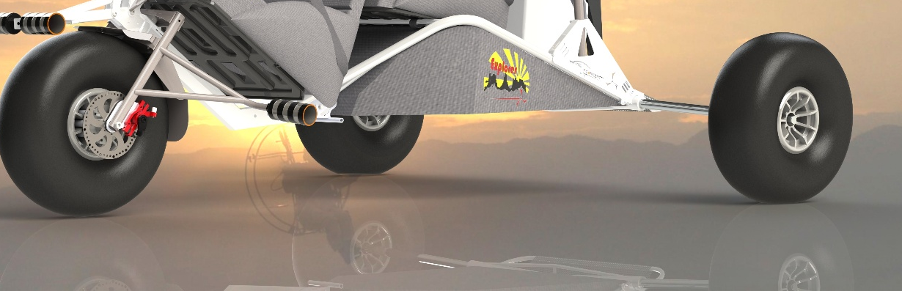

- NOMADIC TWO (2) SIDE EXPLORER CASE (L-R) …………………$95 USD
Adventurer's case with extra straps for attaching fishing rods, tents, fuel, etc., to the outside of the case without taking up internal space. This case is aerodynamic to reduce drag.

- AUXILIARY LIGHTS ……………………………… 187.1 usd,
Includes: two (2) LED lights, waterproof UP67, 50,000 watt (4 functions: white, yellow, and strobe: white and yellow), two (2) red and green LED position indicator lights (strobe light), luxury switch with LED light, 10 meters of #2x18 cable, 4-pin relay and its base, 4 quick connectors for #2x18 cable; all installed inside the structure with cable glands and connected to the panel for later installation to the electrical system of the selected motor. It is HIGHLY RECOMMENDED TO ADD THE MOTOR'S ELECTRICAL INSTALLATION see item #12 (USD 218.2).

- NOMADIC BASIC INSTRUMENTS KIT ………………………………..340usd.

includes: TTO digital RPM tachometer, TTO digital spark plug temperature gauge, TTO digital engine coolant temperature gauge, USB charger (4 ports). HIGHLY RECOMMENDED TO ADD THE ENGINE INSTALLATION KIT (218.2 usd) to ensure everything works correctly and to easily install the engine on your new trike

- NOMADIC COMPLETE ELECTRICAL INSTALLATION KIT FOR VITORAZY ZEUS AND SIMONI VICTOR 1 SUPER ………………………$218. USD
includes: 12V current regulator/rectifier, 12V relay and connector base for dual-ignition engine shutdown, 4-pin relay for auxiliary light contactor, 12-amp starter solenoid, two engine magneto test buttons, toggle switch with protector (master), 7-amp industrial push-button for engine start, 10-amp fuse holder, 8x18 rubber-insulated control wiring, #4 rubber-insulated battery cable (black and red), 8-pin plug-and-play connector, #20 quick-connect wire, 16mm illuminated metal push-button, and wiring for auxiliary lights (lights not included)

- TWO (2) CARABINERS ……………………………………………………… $ 90 USD
Maximum safety with high-capacity steel carabiners (2.4 kN each, which is approximately more than two tons of weight)!
- NOMADIC EXTERNAL PROPELLER GUARD……………………… 295 usd
designed to prevent the wing or lines of the paraglider from entering the propeller directly, preventing damage. Ideal for schools and people who are just beginning to control the wing.
- NEW PHONE HOLDER…………………………………………….$ 35 USD
Suitable for any mobile phone, it features a grip that holds the device firmly in place via compression. It is perfect for use with a passenger harness; for added security, the harness includes a loop where the smartphone can be tethered with a cord in case it falls.

- NEW WELL LINE PROTECTOR………………………………… $35usd.
While our trikes come with a standard line protection system, pilots may opt to replace it with this new accessory, which mounts to the outside of the rim and attaches to the propeller guard ring.

